Water Immersion Sensor
(Wang-shaped Enclosure, 485 Type)

Table of Contents
Chapter 1 Product Introduction ......................................................... 4
1.1 Product Overview
1.2 Features
1.3 Main Parameters
1.4 System Block Diagram
1.5 Product Selection
Chapter 2 Hardware Connection .......................................................... 7
2.1 Pre-installation Inspection
2.2 Wiring
2.3 Installation Method
2.4 Use of the Water Leak Cable
Chapter 3 Configuration Software Installation and Use ..................... 9
3.1 Connecting the Sensor to a Computer
3.2 Using the Sensor Monitoring Software
Chapter 4 Communication Protocol ........................................................ 10
4.1 Basic Communication Parameters
4.2 Data Frame Format Definition
4.3 Register Addresses
4.4 Communication Protocol Examples and Explanations
Chapter 5 FAQ and Troubleshooting ..................................................... 12
Chapter 6 Precautions ............................................................................ 12
Chapter 7 Warranty ............................................................................... 12

Chapter 1 Product Introduction

1.1 Product Overview
This water immersion sensor is widely used in telecommunication base stations, hotels, restaurants, equipment rooms, libraries, archives, warehouses, equipment, cabinets, and other locations that require water-accumulation alarms. It adopts a proprietary AC detection technology, which effectively avoids the reduction in leak-detection sensitivity caused by long-term oxidation of the immersion electrodes. The device offers optional 485 output and switch-contact (dry-contact) output. The 485 output complies with the standard ModBus-RTU protocol, with a maximum communication distance of 2000 m, and can be directly connected to on-site PLCs, industrial control instruments, configuration screens, or configuration software. The external water-leak electrode can extend up to 2600 m, and a water-leak cable up to 2600 m long can also be connected externally. The device uses a waterproof enclosure with a high ingress-protection rating and can operate for extended periods in harsh environments such as damp or high-dust conditions.

1.2 Features
Our company uses alternating current to measure the inductive parameters of accumulated water, accurately determining whether water immersion has occurred, and can even distinguish pure water from tap water (tap water is the default detection target; please specify if pure water is to be detected). Because alternating-current detection is used, the electrodes will not suffer electrophoretic polarization even after prolonged immersion, and no special electrodes are required, achieving long service life and reliable detection.

1.3 Main Parameters
Item | Specification
Supply voltage | DC 10–30 V
Maximum power consumption | Relay output: 1.2 W | RS485 output: 0.4 W
Detection target | Tap water, pure water
Transmitter circuit operating temperature | -20 °C ~ +60 °C, 0% RH ~ 80% RH
Output signal | Relay output: normally-open contact
 | RS485 output: RS485 (ModBus protocol)
 | RS485 + relay output: RS485 (ModBus protocol) + normally-open contact
Wang-shaped enclosure dimensions | 117 × 87 × 43 mm (Max)

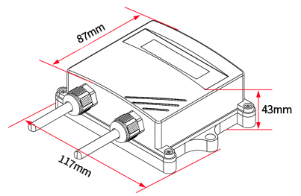

1.4 System Block Diagram
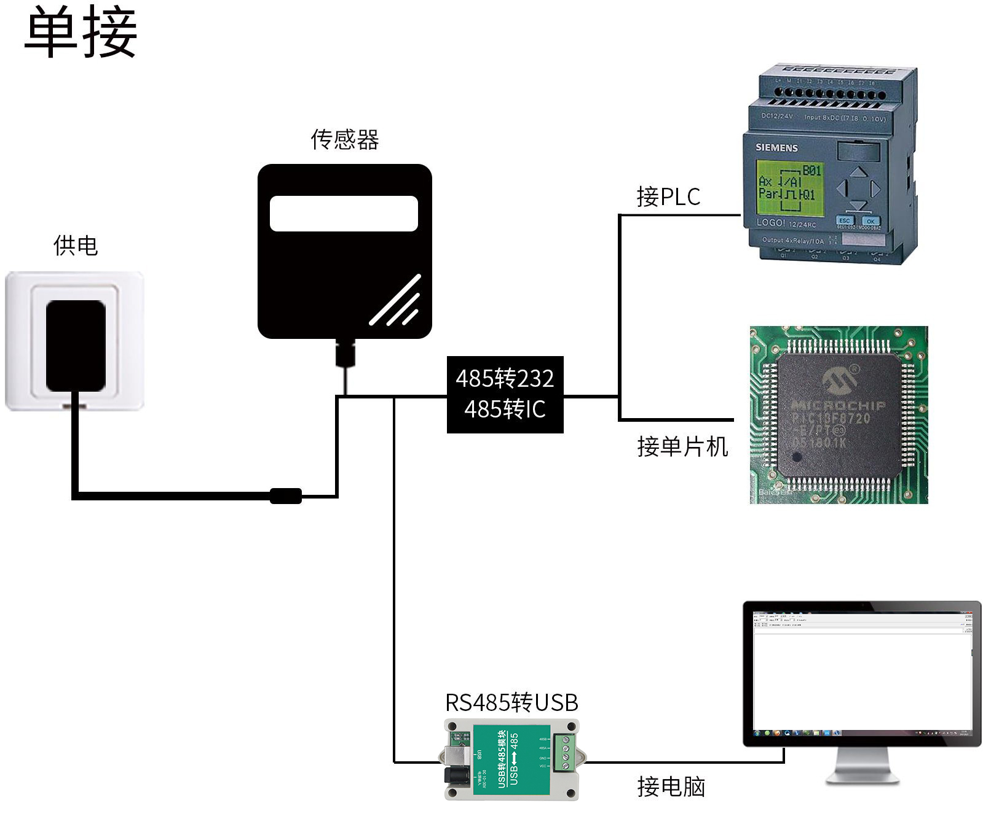
This product can also be used with multiple sensors combined on a single 485 bus. In theory, up to 254 485 sensors can be connected to one bus; the other end connects to a PLC with a 485 interface, to an MCU via a 485 interface chip, or to a computer using a USB-to-485 converter, and is then configured and tested with the sensor configuration tool provided by our company (only one device may be connected when using the configuration software).
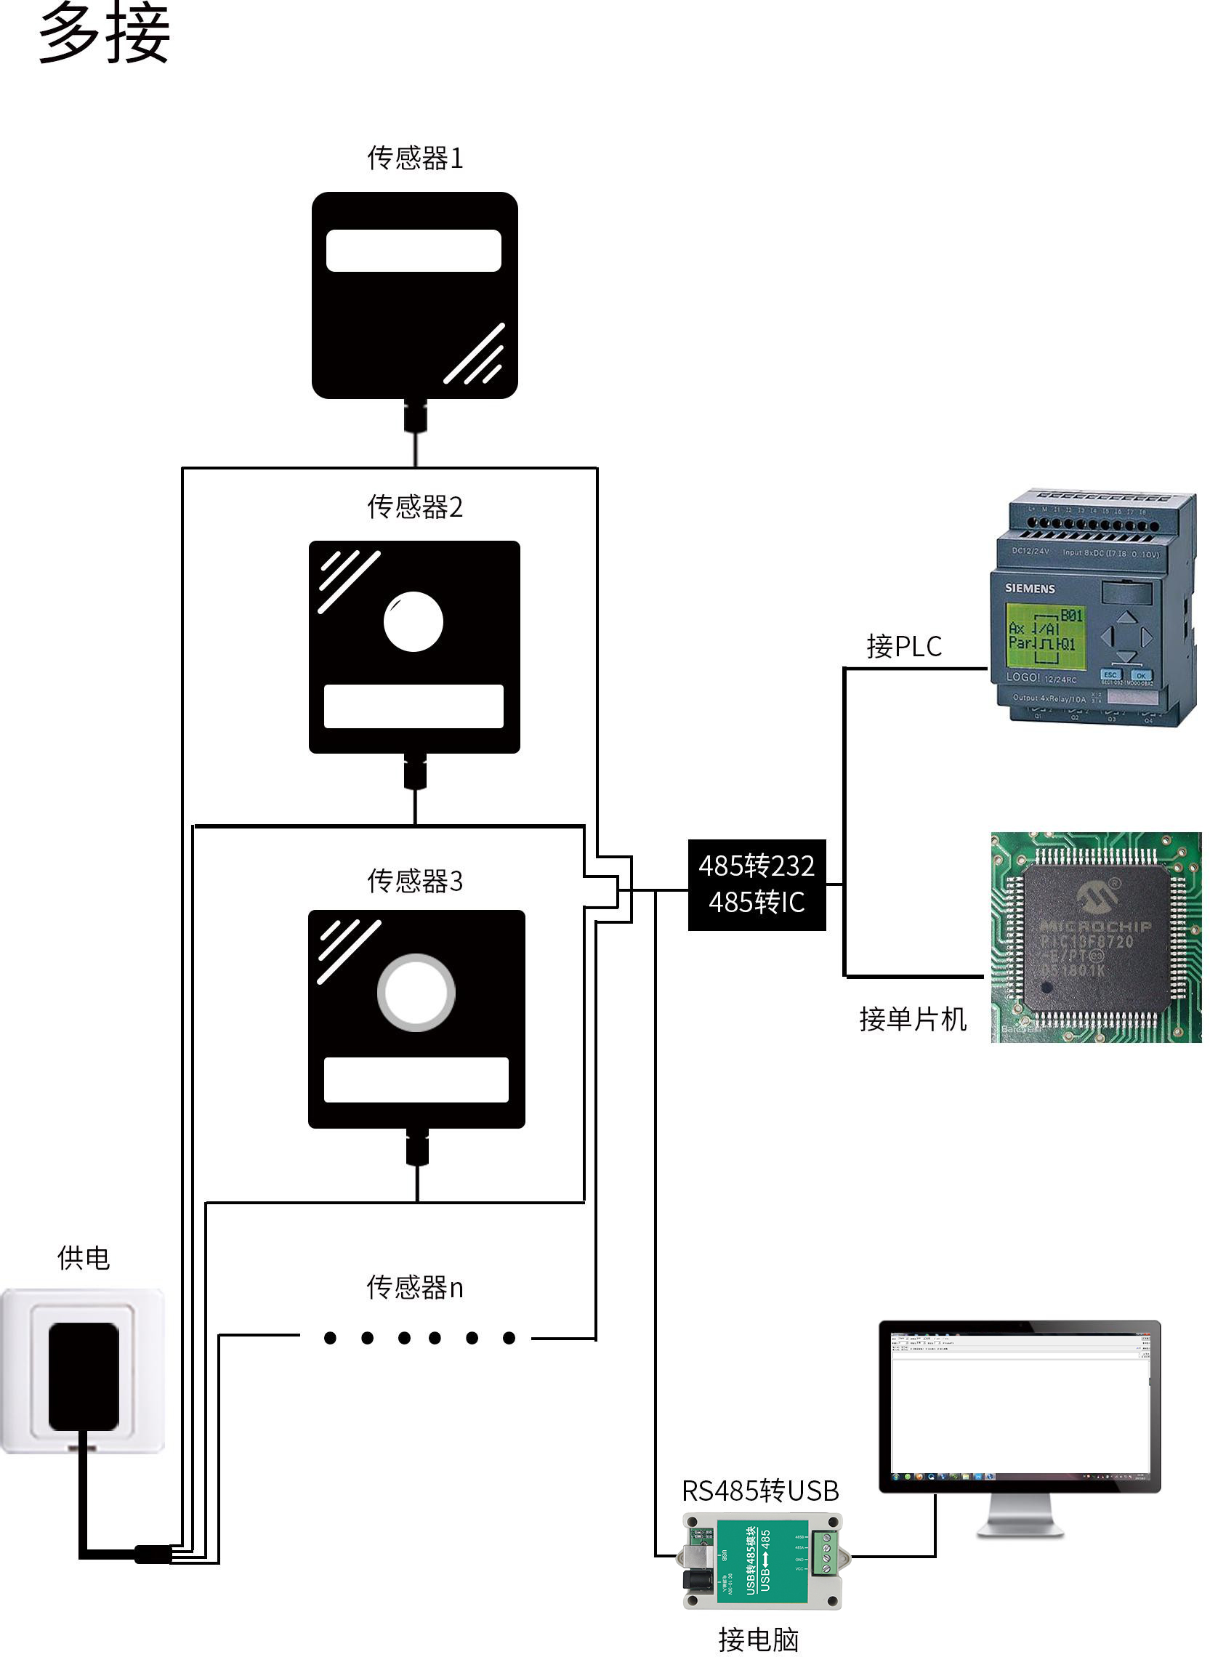

1.5 Product Selection
Model coding:
- SN- Company code
- 3002- Wall-mounted Wang-shaped enclosure
- 300OLED- With OLED screen display
- SJ-
Water immersion transmitter / sensor
- R01 Relay normally-open contact
- N01 RS485 output
- N01R01 RS485 + relay normally-open contact

Chapter 2 Hardware Connection

2.1 Pre-installation Inspection
Equipment list:
- Water immersion sensor unit × 1
- Self-tapping screws (2 pcs), expansion plugs (2 pcs)
- USB-to-485 converter (optional)
- Certificate of conformity, warranty card

2.2 Wiring

2.2.1 Power and 485 Signal Wiring
A wide-range power input of 10–30 V is acceptable. When wiring the 485 signal lines, ensure the A and B lines are not reversed, and that device addresses do not conflict among multiple devices on the same bus.

2.2.2 Relay Interface Wiring
The device comes standard with one relay output; the two outgoing wires are normally-open contacts.

2.2.3 Wiring for Specific Models
Wall-mounted Wang-shaped enclosure wiring:
Category | 485 type | Switch type
Power | Power positive (10–30 V DC) (brown) | Power positive (10–30 V DC) (brown)
 | Power negative (black) | Power negative (black)
Output | 485-A (yellow) | Relay normally-open contact (white, green)
 | 485-B (blue)
Product appearance diagram
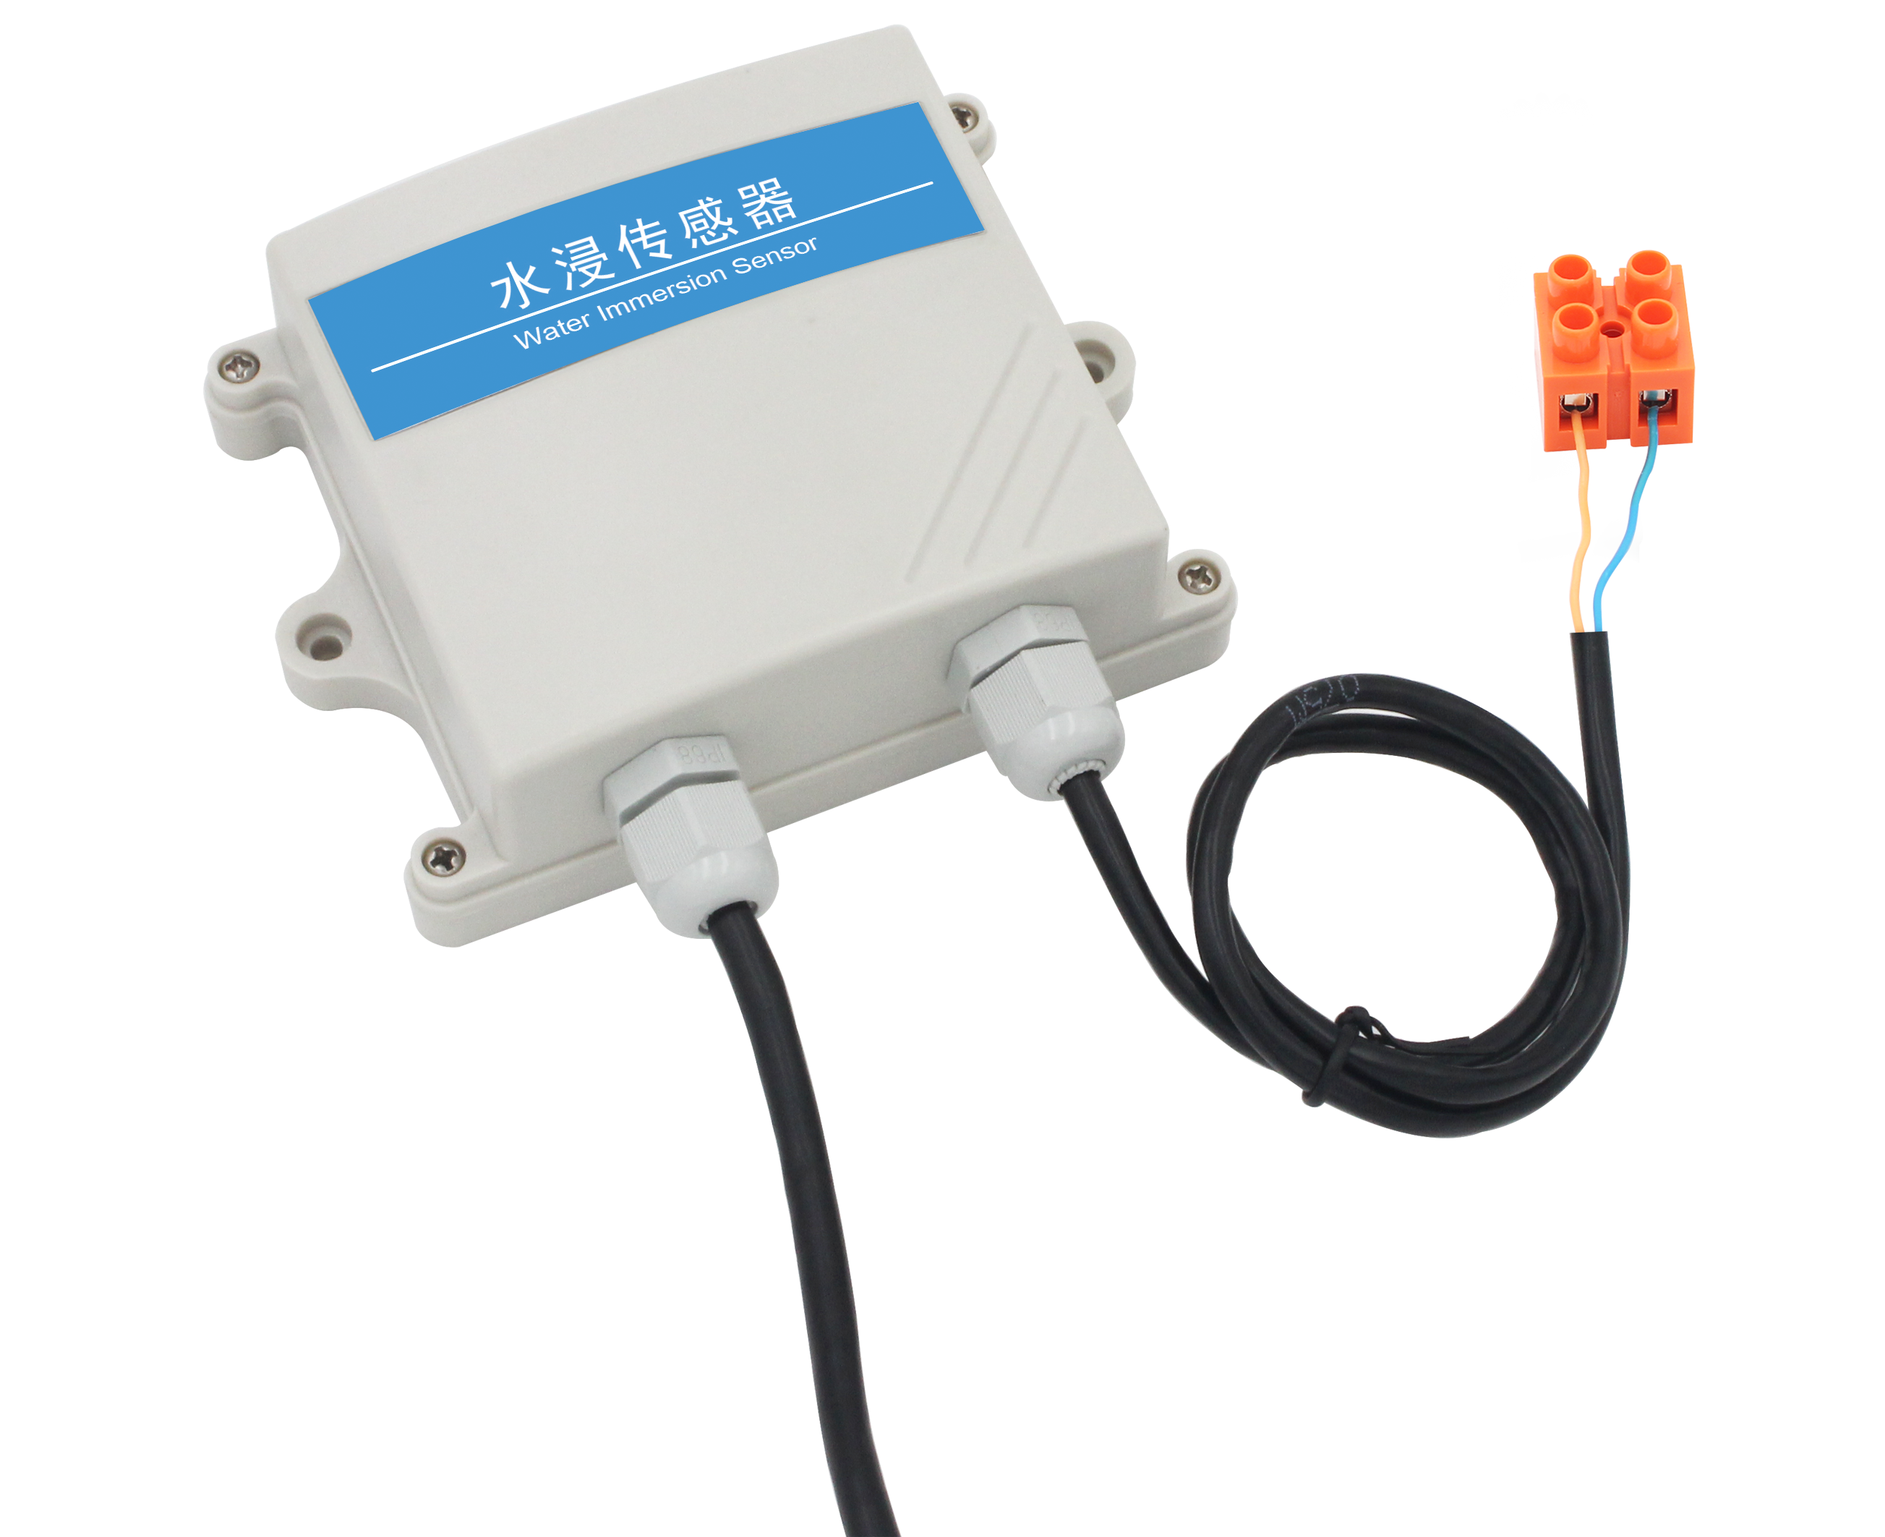

2.3 Installation Method
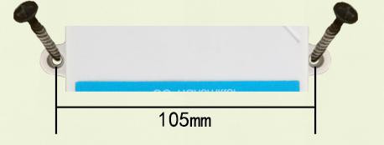

2.4 Use of the Water Leak Cable
For customers who purchase our cable-type water-leak sensors, please note when connecting the water-leak cable that the black wire is the leak-sensing wire, the yellow wire is the support frame, and the black sensing wires at the two ends of the leak cable must not touch each other.
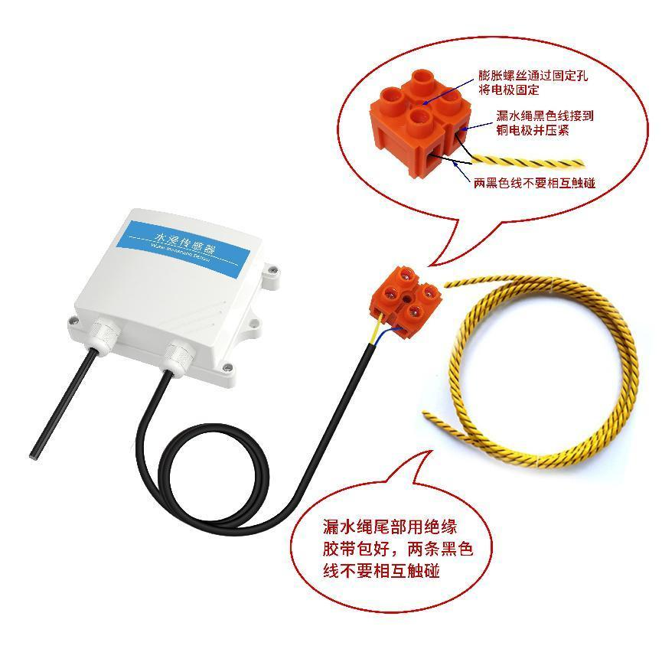

Chapter 3 Configuration Software Installation and Use
Our company provides a companion “485 Parameter Configuration Software” that conveniently allows the computer to read sensor parameters and flexibly modify the sensor's device ID and address.
Note: when using the software's automatic acquisition, ensure that only one sensor is present on the 485 bus.

3.1 Connecting the Sensor to a Computer
After correctly connecting the sensor to the computer via a USB-to-485 converter and providing power, the correct COM port can be seen in the computer (view it under “My Computer — Properties — Device Manager — Ports”).
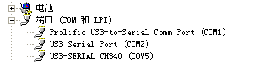
Open the data package, select “Debug Software” — “485 Parameter Configuration Software”, and double-click to open it.
If no COM port is found in Device Manager, it means the USB-to-485 driver (included in the data package) has not been installed or has not been installed correctly. Please contact technical personnel for assistance.

3.2 Using the Sensor Monitoring Software
- In the configuration interface as shown, first obtain the serial port number according to the method in section 3.1 and select the correct serial port.
- Click “Test Baud Rate” in the software; the software will detect the current device's baud rate and address. The default baud rate is 4800 bit/s and the default address is 0x01.
- Modify the address and baud rate as needed, and query the device's current functional status.
- If the test is unsuccessful, please re-check the device wiring and the 485 driver installation.
- 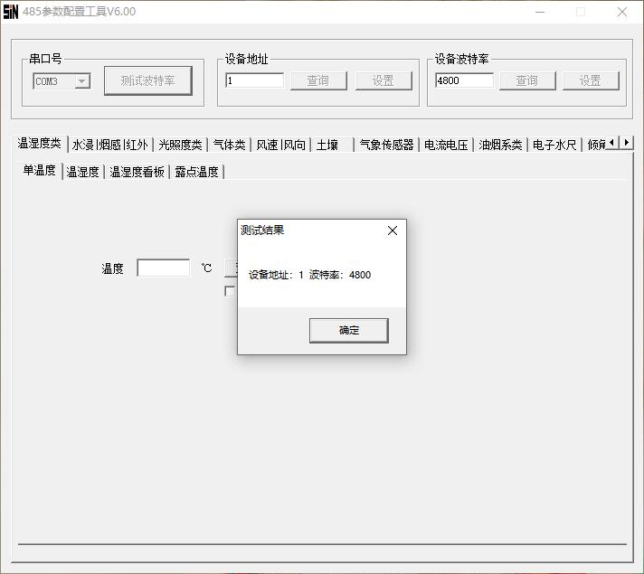

Chapter 4 Communication Protocol

4.1 Basic Communication Parameters
Parameter | Value
Encoding | 8-bit binary
Data bits | 8 bits
Parity bit | None
Stop bit | 1 bit
Error check | CRC (Cyclic Redundancy Check)
Baud rate | 2400 bit/s, 4800 bit/s, 9600 bit/s (selectable); factory default 4800 bit/s

4.2 Data Frame Format Definition
The ModBus-RTU communication protocol is used, with the format as follows:
- Initial structure: ≥ 4 bytes time interval
- Address code = 1 byte
- Function code = 1 byte
- Data area = N bytes
- Error check = 16-bit CRC code
- End structure: ≥ 4 bytes time interval
Address code: the address of the transmitter, unique on the communication network (factory default 0x01).
Function code: indicates the function of the command sent by the host; this transmitter only uses function code 0x03 (read register data).
Data area: the specific communication data; note that for 16-bit data the high byte comes first!
CRC code: a two-byte check code.
Host query frame structure:
Field | Address code | Function code | Register start addr. | Register length | CRC low | CRC high
Bytes | 1 | 1 | 2 | 2 | 1 | 1
Slave response frame structure:
Field | Address code | Function code | Valid bytes | Data area 1 | Data area 2 | … Data N | CRC
Bytes | 1 | 1 | 1 | 2 | 2 | 2 | 2

4.3 Register Addresses
Register Address | PLC / SCADA Address | Content | Operation
0002 H | 40003 | Real-time water immersion status | Read-only
0034 H | 40053 | Current sensitivity | Read / Write

4.4 Communication Protocol Examples and Explanations
Example 1: Read the water immersion status of device address 0x01
Query frame:
Address code | Function code | Start address | Data length | CRC low | CRC high
0x01 | 0x03 | 0x00 0x02 | 0x00 0x01 | 0x25 | 0xCA
Response frame (normal water immersion status):
Address code | Function code | Valid bytes | Data area | CRC low | CRC high
0x01 | 0x03 | 0x02 | 0x00 0x01 | 0x79 | 0x84
Water immersion status description:
Status code | Water immersion status
0x01 | Normal
0x02 | Alarm

Example 2: Set water immersion sensitivity (e.g., 300)
Query frame:
Address code | Function code | Start address | Data length | CRC low | CRC high
0x01 | 0x06 | 0x00 0x34 | 0x01 0x2C | 0xC8 | 0x49
Response frame (current sensitivity = 300):
Address code | Function code | Valid bytes | Data area | CRC low | CRC high
0x01 | 0x06 | 0x00 0x34 | 0x01 0x2C | 0xC8 | 0x49
Sensitivity setting note:
The sensitivity value is inversely proportional to the actual sensitivity: the larger the set value, the less sensitive the detection; the smaller the value, the more sensitive the detection. Note, however, that too small a sensitivity value can easily cause false alarms; it is recommended to use the factory default value.
- Default value: 102
- Range: 0–1024

Chapter 5 FAQ and Troubleshooting
No output or incorrect output
Possible causes:
- The computer has a COM port, but the selected port is incorrect.
- Incorrect baud rate.
- The 485 bus is disconnected, or the A and B wires are reversed.
- Too many devices or wiring too long; supply power locally, add a 485 repeater, and add a 120 Ω termination resistor.
- The USB-to-485 driver is not installed or is damaged.
- Device damage.

Chapter 6 Precautions
WARNING: Risk of personal injury
It is strictly forbidden to use this device as a safety device, an emergency-stop device, or in any situation where device failure could lead to personal injury.
Usage restrictions
This device is for use only within its designed purpose and authorized scope.
Before installation, operation, or maintenance, the relevant instructions in the technical manual must be read and understood carefully.
Failure to observe the above warnings and guidelines may result in death or serious personal injury.
Note: if used together with our water immersion cable, the 3M adhesive sheets for the cable's matching buckles are shipped separately. Before use, stick the 3M sheet onto the buckle first, then proceed with the water immersion cable installation.

Chapter 7 Warranty
This product enjoys a 12-month warranty from the date of purchase (subject to a valid proof of purchase). Within the warranty period, under normal use and maintenance, if a fault is caused by product material or workmanship defects and confirmed by our company's inspection, we will provide free repair or parts-replacement service (note: the circuit board carries a 24-month warranty, and the water immersion cable carries a 6-month warranty). After the warranty period expires, we will still provide you with lifetime paid repair service.
The following cases are not covered by the warranty:
- Damage caused by incorrect installation or operation.
- Having been disassembled, repaired, modified, or altered by non-company technical personnel, or any component replaced by the user.
- Damage caused by negligent use or by water or other substances entering the device.
- Faults or damage caused by accidents or natural disasters.
- Faults or damage caused by exceeding the working-parameter ranges listed in the product parameters.

